FORM B
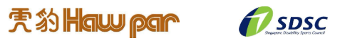
PHOTOGRAPHY AND VIDEOGRAPHY REFUSAL FORM

Full Name of Participant:
Event: | Haw Par National Youth Para Swimming Championships 2026
I refuse permission for the use of images of my child or myself by the Organiser.

Signed by: (Name of Participant / Parent / Caregiver) Date:

Closing Date: 12 August 2026
Submit to nurul.fiona@sdsc.org.sg

