



ENTRY FORM
NATIONAL PARA TABLE TENNIS CHAMPIONSHIPS 2026

Name of Team Manager / Person-in-Charge
Organization / School
Contact Number | (Office) | (Mobile)
Email
Please refer to entry information given for table of events and classification.
Entries will be void if the events and classification registered is/are not in accordance to the entry’s specifications
Please enter clearly and duplicate form for additional participants, if necessary.

PARTICIPANTS

Age Group
Open: 20 years old and above (Born in the year 2006 and before)
U20: 17 – 19 years old (Born between 2009 – 2007)
U17: 13 – 16 years old (Born between 2010 – 2013)
U13: 7 – 12 years old (Born between 2019 – 2014)

Sport Class
TT1 - TT5: Physical Impairment, PI (Wheelchair)
TT6 - TT10 Physical Impairment, PI (Standing)
TT11: Intellectual Impairment
New: New, not yet classified
No | Participant Full Name | Age | Gender | Tshirt size | Citizen/ PR/ Foreigner | Age Group | Sport Class
E.g 1. | Tan Kim Yi | 17 | F |  | Citizen | U20 | TT5

OFFICIALS

Officials eligible for accreditation:
- Team Manager (TM)
- Coach (C)
- Caregiver (CG) (Limited to participants who require additional physical or social assistance; capped at 1 caregiver per participant)
* To align with the capacity of Field of Play, SDSC reserves the right to issue the number of passes to the application.

No | Official Full Name | Gender | Tshirt size | Accreditation (TM / C / CG) | For CG: Please state full name of participant to be supported
E.g. 1. | Goh Siew Ting | F |  | CG | Tan Kim Yi

Total No.

Closing Date: 9 March 2026
Submit to: chiho.yoon@sdsc.org.sg

FORM B
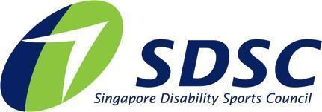

PHOTOGRAPHY AND VIDEOGRAPHY REFUSAL FORM

Full Name of Participant:
Event: | National Para Table Tennis Championships 2026
I refuse permission for the use of images of my child or myself by the Organiser.

Signed by: (Name of Participant / Parent / Caregiver) Date:

Closing Date: 9 March 2026
Submit to: chiho.yoon@sdsc.org.sg

