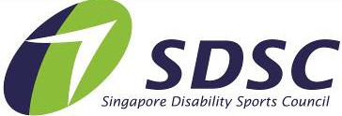

NATIONAL PARA SWIMMING CHAMPIONSHIPS 2024
&
PARA SWIMMING INTER-SCHOOL CHAMPIONSHIPS 2024
Events, Categories & Classification
Please apply the following abbreviation for swim events
Freestyle: Breaststroke: Backstroke: Butterfly:
Fr Br Bk Fly

Relay (Fr) 4 x 50m: 4 x 50

Example: 50M Freestyle
= Fr50
Categories

National Championships
Open Division: 15 years old and above (Born in 2009 and before)

Inter-School Championships
Under-20 (U20): 17 – 19 years old (Born between 2007 – 2005)
Under-17 (U17): 15 – 16 years old (Born between 2009 – 2008)
Under-15 (U15): 13 – 14 years old (Born between 2011 – 2010)
Under-13 (U13): 10 – 12 years old (Born between 2014 – 2012)
Under-10 (U10): 7 – 9 years old (Born between 2017 – 2015)

Classification

Physical Impairment, PI
Visual Impairment, VI
Intellectual Impairment, II
Deaf/Hard of Hearing, HI
Autism
Down Syndrome
(Classes: S1 – S10) (Classes: S11 – S13) (Class: S14)
(Class: S15)
(Class: II3)
(Class: II2)

FORM A
PLEASE NOTE
This registration form is for ALL Participants Please print duplicate copies where necessary.
NATIONAL PARA SWIMMING CHAMPIONSHIP 2024
Name of Team Manager / Person-in-Charge
Organization / School (if applicable)
Contact Number | (Office) | (Mobile)
Email

PARA SWIMMING INTER-SCHOOL CHAMPIONSHIPS 2024

ENTRY FORM
Please refer to entry information given for table of events and classification.
Entries will be void if the events and classification registered is/are not in accordance to the entry’s specifications Note that all registered events must state the actual / estimated entry time (seed time).
Please enter clearly and duplicate form for additional participants, if necessary. Accreditations are not transferable.

PARTICIPANTS
No | Participant Full Name | Age | Gender | Year born | Sport Class | Event &  Seed Time | Event &  Seed Time | Event &  Seed Time | Event &  Seed Time | Event &  Seed Time
E.g. 1. | Tan Kim Yi | 7 | F | 2017 | II3 | FR100  Mm:ss.00 (eg)1:01.01 | FLY100 1:05.04 | BK100 1:07.21 | BK50 00:35.21 | FR 50  00:40:03

OFFICIALS

Officials eligible for accreditation:
- Team Manager (TM)
- Coach (C)
- Caregiver (CG) (Limited to participants who require additional physical or social assistance; capped at 1 caregiver per participant)

No | Official Full Name | Gender | Accreditation (TM / C / CG) | For CG: Please state full name of participant to be supported
E.g. 1. | Goh Siew Ting | F | CG | Tan Kim Yi

Total No.

FORM B
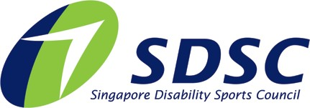

PHOTOGRAPHY AND VIDEOGRAPHY REFUSAL FORM

Full Name of Participant:
Event: | National Para Swimming Championships 2024  Para Swimming Inter-School Championships 2024
I refuse permission for the use of images of my child or myself by the Organiser.

Signed by: (Name of Participant / Parent / Caregiver) Date:

Closing Date: 8 March 2024
Submit to jessica.chua@sdsc.org.sg

