APPLICATION FORM
(
For Individual Membership
)
PART A : PARTICULARS
Name (Dr/ Mr/ Mrs/ Ms/ Mdm):
Address:
Date of Birth:
Mobile number:
dd/mm/yyyy
Email Address:
Please indicate your involvement/role in para sport
Name of sport: ______________
Educational Qualifications:
Athlete
Technical Official
Coach
Others:
please specify
PART B: EMPLOYMENT DETAILS
Company/Organisation:
Designation:
PART B: MEMBERSHIP APPLIED FOR:
Individual Membership (S$12 per annum)
Reason(s) for Application:
PART C: DECLARATION BY APPLICANT
I hereby declare that the above particulars are correct and that I agree to abide by the rules and regulations of the Singapore
Disability Sports Council.
By the submission of this form, I agree that the Singapore Disability Sports Council ("SDSC") may collect, use and disclose my
personal data, as provided in this application form, for the purposes in accordance with the Personal Data Protection Act 2012, the
application of SDSC Membership.
_____________________________________
_________________________________________
Signature
Date
The Data Protection relates to the information (Data) supplied by you to Singapore Disability Sports Council (“SDSC”) voluntarily as provided in this application form. The Personal
Data that is collected from you is used and/or disclosed for the following purposes, which include but are not limited to:
Processing of the application of membership, carrying out Marketing and communicating with you in relation to activities and services offered by SDSC;
SDSC will make every effort to ensure that its employees who are involved in the collection, use and disclosure of Personal Data will observe and adhere to the terms of this Privacy
Policy in accordance to the Personal Data Protection Act 2012. Please be assured that SDSC has put in place preventative measures to safeguard the personal data stored with us.
SDSC will retain your Personal Data for as long as it is necessary to fulfil the business purposes for which it is collected, or as required by the relevant law. You may request to make
corrections to your personal data held by us, by writing to: sdsc@sdsc.org.sg. You can also write to this email for any questions or feedback relating our Privacy Policy. We may
amend this policy from time to time to ensure that this policy is consistent with any developments to the way SDSC uses your personal data or any changes to the laws and
regulations applicable to SDSC. We will publish the updated policy on our website.
PART D: MODE OF PAYMENT
PAYNOW
Step 1:
Login to your bank app
Step 2:
Under 'Transfer', scan the
QR code
or key in UEN: S73SS0035B in your bank's app PayNow page
Step 3:
Enter the transaction amount
Step 4:
Indicate your name in the reference/notes box
Step 5:
Verify details, and submit
BANK TRANSFER
Account name : Singapore Disability Sports Council
Bank Name : DBS Ltd, Singapore (Swift Code: DBSSS GSG)
Bank A/C : 033-021741-2 (Branch Code: 033)
Bank Name : DBS Ltd, Singapore (Bank Code: 7171)
PART E: FOR OFFICIAL USE
Amount received:
$
Date:
PayNow/ Bank Transfer
Receipt Number:
Remarks:

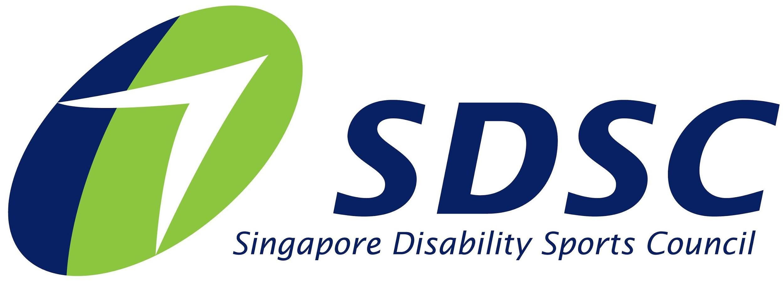
Parent/Guardian Consent Form
for Participants Under the Age of 18

Singapore Disability Sports Council
3 Stadium Drive Singapore 397630

CONSENT FORM FOR PARTICIPATION OF MINORS

I, _______________________ (Full Name in NRIC), ____________________ (NRIC Number) who is _________________ (Relationship), of ____________________ (Name of applicant), ____________________ (NRIC Number of applicant) hereby give my consent for my child/ward to be an individual member of Singapore Disability Sports Council (SDSC).

ACKNOWLEDGEMENTS
I also undertake that neither I nor my *son/daughter/ward shall hold SDSC, its staff, officers, any other relevant personnel or any of its authorised agents responsible for any damage, loss or injury sustained by my *son/daughter/ward during the period of membership unless such damage, loss or injury is caused by the negligence of SDSC, its staff, officers, or any other relevant personnel.

PARENT/GUARDIAN INFORMATION
Contact Number:

Address (if it differs from applicant):

Date
Signature of Parent/Guardian

Please return this signed consent form to Singapore Disability Sports Council. If you have any questions or concerns, please contact us at (65) 6342 3501 or sdsc@sdsc.org.sg.

Thank you for your cooperation.

Sincerely,
Singapore Disability Sports Council

