ENTRY FORM
NATIONAL PARA TABLE TENNIS CHAMPIONSHIPS 2024

Name of Team Manager / Person-in-Charge
Organization / School
Contact Number | (Office) | (Mobile)
Email
Please refer to entry information given for table of events and classification.
Entries will be void if the events and classification registered is/are not in accordance to the entry’s specifications
Please enter clearly and duplicate form for additional participants, if necessary.

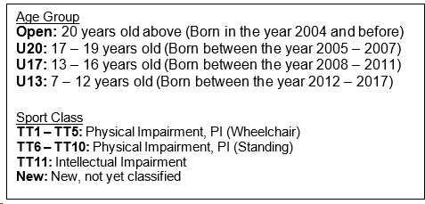
PARTICIPANTS
No | Participant Full Name | Age | Gender | Citizen/ PR/ Foreigner | Age Group | Sport Class
E.g 1. | Tan Kim Yi | 17 | F | Citizen | U20 | TT5

OFFICIALS

Officials eligible for accreditation:
- Team Manager (TM)
- Coach (C)
- Caregiver (CG) (Limited to participants who require additional physical or social assistance; capped at 1 caregiver per participant)
* To align with the capacity of Field of Play, SDSC reserves the right to issue the number of passes to the application.

No | Official Full Name | Gender | Accreditation (TM / C / CG) | For CG: Please state full name of participant to be supported
E.g. 1. | Goh Siew Ting | F | CG | Tan Kim Yi

Total No.

Closing Date: 19 FEB 2024
Submit to: chiho.yoon@sdsc.org.sg

FORM B
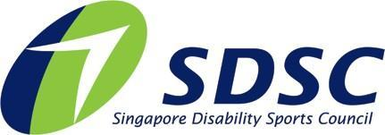

PHOTOGRAPHY AND VIDEOGRAPHY REFUSAL FORM

Full Name of Participant:
Event: | National Para Table Tennis Championships 2024
I refuse permission for the use of images of my child or myself by the Organiser.

Signed by: (Name of Participant / Parent / Caregiver) Date:

Closing Date: 19 FEB 2024
Submit to: chiho.yoon@sdsc.org.sg

