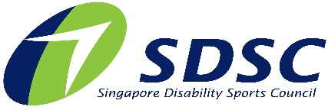

SINGAPORE DISABILITY SPORTS COUNCIL (SDSC)
CHARITY GOLF 2023
PLEDGE OF SUPPORT
Date: 24 August 2023 | Venue: Tanah Merah Country Club (Garden Course)

You can support the SDSC Charity Golf 2023 through any of the following ways:
- Book a Supporter Package
- Participate in Golf Tournament
- Make a Cash Donation
- Donation in Kind (e.g. Goodie Bags, Prizes)

☐ BOOK A SUPPORTER PACKAGE
Tier | Albatross  $30,000 | Eagle  $20,000 | Birdie  $10,000
Preferred Package  (Please Tick) | ☐ | ☐ | ☐
Flights included in package | 3 Flights | 2 Flights | 1 Flight
Token of Appreciation | - Corporate logo will be acknowledged on photo wall and website  - 250% tax exemption  - For more information, please refer to the Annex.
☐ PARTICIPATE IN GOLF TOURNAMENT
Support the cause by taking up a flight(s) (4 golfers per flight) at $5,000
☐ MAKE A CASH DONATION
Please indicate amount: _____________________________

☐ DONATION IN KIND
Product and Quantity | ☐ for goodie bags  ☐ for lucky draw / golf tournament prizes  ☐ for golf tournament refreshments  ☐ for auction
Value of Donation (for recording purposes only)

- METHOD OF PAYMENT

☐ Cheque | Make cheque payable to 'Singapore Disability Sports Council'.  Behind the cheque, indicate ‘Charity Golf 2023’, your name/name of organisation and NRIC/FIN/UEN.  Mail it to Singapore Disability Sports Council, 3 Stadium Drive, #01-34, Singapore 397630.
☐ Bank Transfer | Account Name: Singapore Disability Sports Council  Bank Name: DBS Ltd, Singapore  Bank A/C: 033-021741-2  Swift Code: DBSSS GSG  Indicate “CharityGolf” in the transaction details.
☐ PayNow | 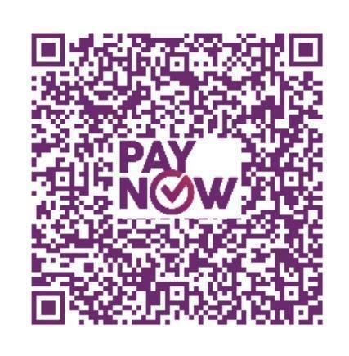  Key in UEN: S73SS0035B or scan this QR Code.  Indicate “CharityGolf” in the transaction details.

- DONOR PARTICULARS
a | I am donating as an  ☐ Individual - Full Name (as per NRIC / FIN):  ☐ Organisation - Name (as per ACRA / ROS):
b | The Singapore Disability Sports Council (SDSC) is a charity under the National Council of Social Service (UEN: S73SS0035B) and an Institute of Public Character. All donations above $50 will be entitled to 2.5 times tax exemption. A tax-deductible receipt will be issued upon request. For more information about the tax benefits, please refer to www.iras.gov.sg.  I would like a tax exemption receipt:  ☐ Yes  My NRIC / UEN number is:  ☐ No
c* | ☐ (Please check / tick to acknowledge this) I agree that my donation would be submitted for matching by the Tote Board Enhanced Fundraising Programme OR the One Team Singapore Fund (OTSF), to multiply its impact for SDSC. If my donation is submitted for OTSF, it shall benefit purposes relating to and/or arising from the SDSC’s High Performance Sport System.

Contact Details
Name:
Designation:
Mailing Address:
Contact Number: | (O): _____________ (M): _____________
Email:

- TERMS AND CONDITIONS
- Orders will only be processed / confirmed upon receipt of payment.
- Any amounts received above the required amount will be considered an outright donation.

- SUBMISSION AND ENQUIRIES
Please email to charitygolf23@sdsc.org.sg or call 6342 3501.

Entitlements for Supporter Packages for SDSC Charity Golf 2022
 | Albatross | Eagle | Birdie
Donation Sum or Value | $30,000 | $20,000 | $10,000
Number of Golfers | 12 | 8 | 4
Lunch for golfers | ✓ | ✓ | ✓
Dinner for golfers | ✓ | ✓ | ✓
Website acknowledgement | ✓ | ✓ | ✓
Special invitation to VIP table | ✓
Social media post acknowledgement | ✓ | ✓
Acknowledgement on Event Photo Wall (on green) | ✓ | ✓
Acknowledgement on A-boards (on green) | ✓ | ✓
Acknowledgement on dinner event | ✓ | ✓
Token of Appreciation | ✓ | ✓
250% tax deduction | ✓ | ✓ | ✓

