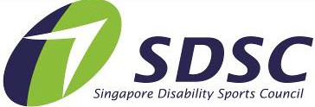

HAW PAR NATIONAL YOUTH PARA SWIMMING CHAMPIONSHIPS 2022
Division & Classification

19 & Above (Born in 2003 and before) – Time Trial only (non-medal events)
17 - 18 years old (Born between 2005– 2004)
15 - 16 years old (Born between 2007 – 2006)
13 - 14 years old (Born between 2009 – 2008)
11 – 12 years old (Born between 2011 – 2010)
9 – 10 years old (Born between 2013 – 2012)
7 – 8 years old (Born between 2015 – 2014)
Physical Impairment, PI Visual Impairment, VI Intellectual Impairment, II Deaf and Hard of Hearing, HL Autism
Intellectual Disability with Additional Impairment
(Classes: S1 – S10) (Classes: S11 – S13) (Class: S14)
(Class: S15) (Class: II3) (Class: II2)
Events, Division & Classification
Please apply the following abbreviation for swim events
Freestyle: Breaststroke: Backstroke: Butterfly:
Finisher Race
Fr Br Bk Fly
25F
Relay (Fr) 4 x 50m: 4 x 50

Example: 50M Freestyle
= Fr50

FORM A
HAW PAR NATIONAL YOUTH PARA
PLEASE NOTE
This registration form is for ALL Participants Please print duplicate copies where necessary.
SWIMMING CHAMPIONSHIPS 2022 ENTRY FORM
Name of Team Manager / Person-in-Charge
Organisation / School (if applicable)
Contact Number | (Office) | (Mobile)
Email

Please refer to entry information given for table of events and classification.
Entries will be void if the events and classification registered is/are not in accordance to the entry’s specifications Note that all registered events must state the actual / estimated entry time (seed time).
Please enter clearly and duplicate form for additional participants, if necessary. Accreditations are not transferable.

PARTICIPANTS
No | Participant Full Name | Age | Gender | D.O.B | Class | Event &  Seed Time | Event &  Seed Time | Event &  Seed Time | Event &  Seed Time | Event &  Seed Time | T-Shirt  XS/S/M/L
E.g. 1. | Tan Kim Yi | 7 | F | 01/01/1980 | II3 | FR100  Mm:ss.00 (eg)1:01.01 | FLY100 1:05.04 | BK100 1:07.21 | BK50 00:35.21 | FR 50  00:40:03 | m

OFFICIALS

Officials eligible for accreditation:
- Team Manager (TM)
- Coach (C)
- Caregiver (CG) (Limited to participants who require additional physical or social assistance; capped at 1 caregiver per participant)

* To align with the Covid19 crowd control, SDSC reserve the right to issue the number of passes to the application.

No | Official Full Name | Gender | Accreditation (TM / C / CG) | For CG: Please state full name of participant to be supported
E.g. 1. | Goh Siew Ting | F | CG | Tan Kim Yi

Total No.

FORM B
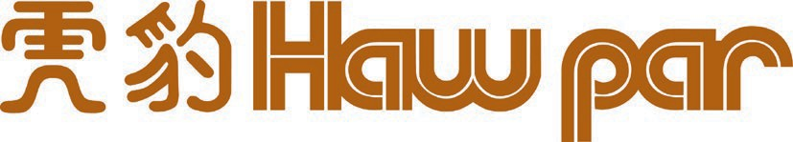
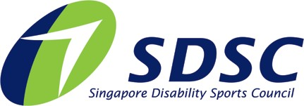

PHOTOGRAPHY AND VIDEOGRAPHY REFUSAL FORM

Full Name of Participant:
Event: | Haw Par National Youth Para Swimming Championships 2022
I refuse permission for the use of images of my child or myself by the Organiser.

Signed by: (Name of Participant / Parent / Caregiver) Date:

Closing Date: 29th August 2022
Submit to jessica.chua@sdsc.org.sg

