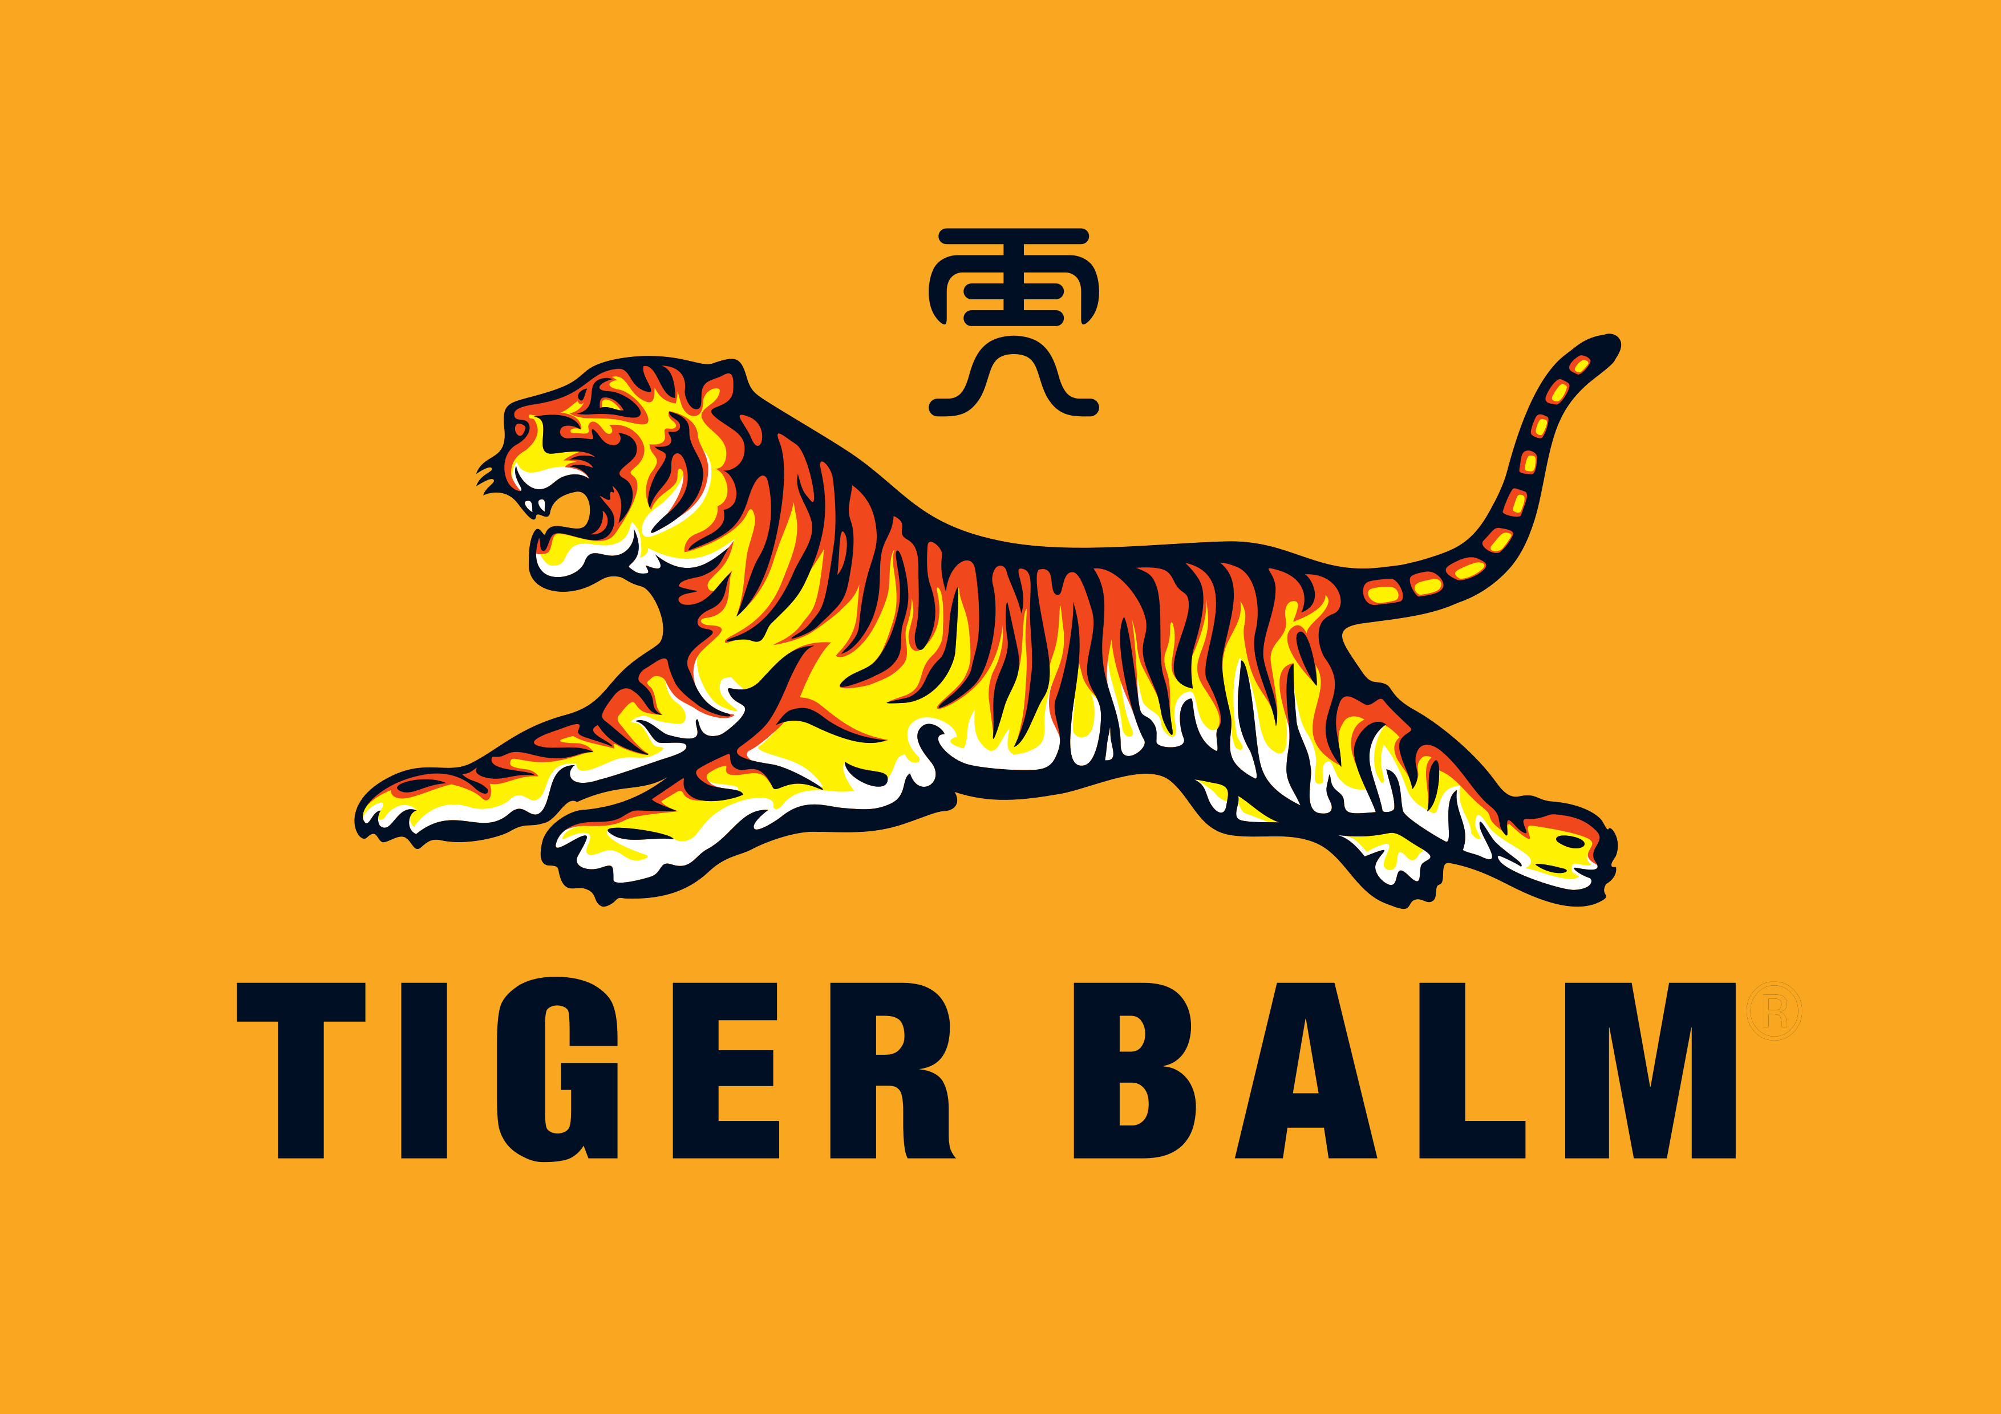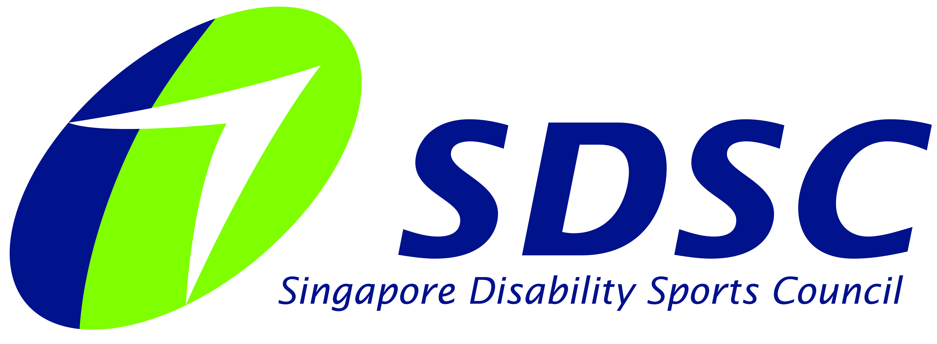
FORM A
TIGER BALM NATIONAL BOCCIA CHAMPIONSHIPS 2021

FORM A

ENTRY FORM

Name of Team Manager / Person-in-Charge

Organisation / School (if applicable)
Contact Number | (Office) | (Mobile)

Email

Safe Management Measures (SMM) allows group / “bubble” size to 8 pax (athletes + caregivers + sport assistants), with an additional coach. (I.e. maximum = 9 pax including coach). Please keep group size as small as possible. We have to consider that the venue allows only 50 pax in total. Please appoint more than 1 group lead if necessary if your organisation or team has multiple groups entry.
Thank You!

PARTICIPANTS

No | Participant Full Name | Age | Gender | D.O.B | Class (BC1, BC2, BC3, BC4 or N.A.) | Roles  (Athlete / Athlete Competition Partner / Coach / Caregiver / Sport Assistant) | Diet  (Veg or Non Veg)
1
2
3
4
5
6
7
8
9

PLEASE NOTE
This registration form is for ALL Participants
Please print duplicate copies where necessary.

Registration Deadline: 1 May 2021

FORM B

PHOTOGRAPHY AND VIDEOGRAPHY REFUSAL FORM

Full Name of Participant:
Event: | TIGER BALM NATIONAL BOCCIA CHAMPIONSHIPS 2021

I refuse permission for the use of images of my child or myself by the Organiser.

_______________________________________
Signed by: (Name of Participant / Parent / Caregiver)
Date:

