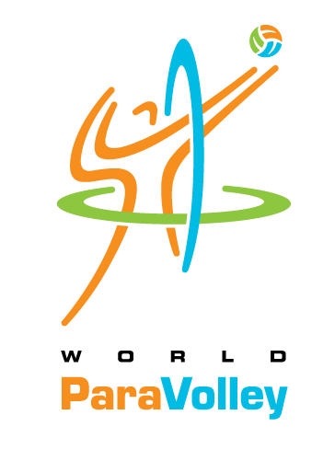
World ParaVolley Level 1 Coach Course
March 23-28, 2018 – Jeju City, South Korea

Candidate Registration Form – Deadline 16 February 2018
COURSE FEE PAYMENT – DEADLINE: 16 February 2018

Participant’s Personal Information
FAMILY Name: |  |  |  |  |  | GIVEN Name(s):
Nationality: |  |  |  |  |  | Gender:
Passport #: |  |  | Expiry date: |  |  |  | Place of issue:
Date of Birth: |  |  |  | Place of Birth:
Profession:
Contact Information
Address:
Home Phone: |  |  |  |  |  |  |  | Mobile:
E-mail address: |  |  |  |  |  |  |  | SKYPE Name:
Languages Spoken:
Coaching Information / Technical Qualification
Highest Coaching Qualification
Level: |  |  |  |  | Year: |  |  |  | Country:
Other Qualification / Experience
Year | Location (country) | Qualification / Experience

I hereby confirm that all information provided above is true and correct. I will conform to the Rules & Regulations of the Course. I fully understand that my participation is at my own risk in all respects and will not hold World ParaVolley or the LOC responsible for any mishaps, accidents, etc. I promise to ensure the full fees as advertised in the invitation letter are paid, to complete the full duration of the course and to undergo all evaluations conducted.

Participant Signature: Date:

CERTIFICATION / VERIFICATION
(by World ParaVolley Member, NPC, or National Volleyball Federation)
The World ParaVolley Member Nation, NPC or Volleyball Federation supports the above candidate to participate in the World ParaVolley Level 1 Coaches Course –March 23-28, 2018, Jeju City, South Korea.

Official Seal of the WPV Member,
NPC or National VB Federation

Federation Name:

(Signature of Official)
Name:
Function:
Date:

IMPORTANT: Please return the Registration Form by e-mail by 16 February 2018 to:
Ms. Malsoon Jung, KOVAD  Mr. Steve Jones, Instructor  Mr. Weiping Tu, Instructor  Mr. Phil Allen, World ParaVolley General Manager  Mr. Denis Le Breuilly, World ParaVolley Sport Director | volleykr@naver.com  jones.stevejones.steve6@gmail.com  tuweiping1@hotmail.com  generalmanager@worldparavolley.org  sportdirector@worldparavolley.org

