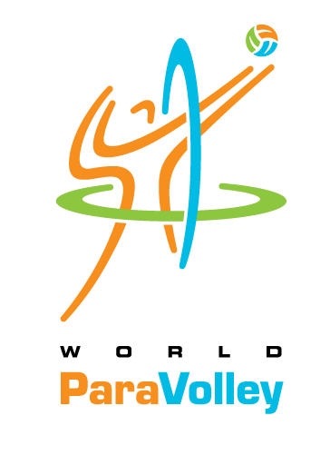
World ParaVolley Level 1 Classification Course
March 23-28, 2018 – Jeju City, South Korea

Candidate Registration Form – Deadline 16 February 2018
COURSE FEE PAYMENT – DEADLINE: 16 February 2018

Participant’s Personal Information
FAMILY Name: |  |  | GIVEN Name(s):
Nationality: |  |  | Gender:
Passport #: | Expiry date: |  |  |  |  |  | Place of issue:
Date of Birth: |  | Place of Birth:
Profession:
Contact Information
Primary Address:
Home Phone: |  |  |  |  | Mobile:
E-mail address: |  |  |  |  | SKYPE Name:
Languages Spoken:
Profession and Qualifications
Highest Medical Qualification:
Level: | Year: |  |  |  |  | Country:
Relation to NPC / NF
Attachments
Resume / CV: Proof of Qualification:
Please provide a copy of your Medical or Physiotherapy Degree, License to Practice, and Curriculum Vitae

I hereby confirm that all information provided above is true and correct. I will conform to the Rules & Regulations of the Course. I fully understand that my participation is at my own risk in all respect and will not hold World ParaVolley or the LOC responsible for any mishaps, accidents, etc. I promise to ensure the full fees as advertised in the invitation letter are paid, to complete the full duration of the course and to undergo all evaluations conducted.

Participant Signature: Date:

CERTIFICATION / VERIFICATION
(by World ParaVolley Member, NPC, or National Volleyball Federation)
The World ParaVolley Member Nation, NPC or Volleyball Federation supports the above candidate to participate in the World ParaVolley Level 1 Classification course – March 23-28, 2018 – Jeju City, South Korea.
Official Seal of the WPV Member,
NPC or National VB Federation

Federation Name:

(Signature of Official)
Name:
Function:
Date:

IMPORTANT: Please return the Registration Form by e-mail by 16 February 2018 to:
Ms. Malsoon Jung, KOVAD  Ms. Jurate Kesiene, Course Instructor  Ms Jenni Cole, Course Instructor  Dr. Jinzhong Ma, PVAO Classification Chair  Ms. Louise Ashcroft, World ParaVolley Medical Director  Mr. Phil Allen, World ParaVolley General Manager  Mr. Denis Le Breuilly, World ParaVolley Sport Director | volleykr@naver.com  jurate.kesiene@santa.lt  jenni.anne.1967@gmail.com  majinzhong007@sina.com  medicaldirector@worldparavolley.org  generalmanager@worldparavolley.org  sportdirector@worldparavolley.org

